Function name:

name: ‘sign_in’

Input parameters:

data: {

avatarUrl: ‘example_url’,

nickname: ‘example_name’,

gender: 0

}

notes: data should be a json file.

Nickname and avatarUrl should be strings. Gender is a num in the range [0, 3].

Nickname could be an empty string

Data returned:

Case 1: New user registers and returning user

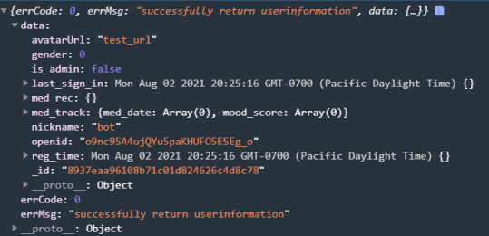

Case 2: gender or avatarUrl is not passed in as parameters.

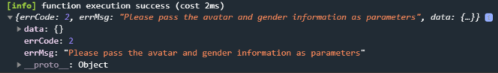

Case 3: err_code == 1 means the App is NOT able to get OPENID from cloud.getWXContext()